FOUNDATION FOR VIRTUAL AND AUGMENTED REALITY SYSTEMS
Lecture40
Lec-40: System Design
Hello and welcome to the NPTEL MOOCs course on Foundations of Virtual and Augmented Reality Systems. We are currently discussing aspects of system design, and we have already covered a few topics, and we are going to cover a few more in this part of the lecture. So, essentially, we are talking about how to design immersive experiences, and in that context, we have already talked about interaction techniques and their importance. We have covered one interaction technique, that is, object interaction.
So, if you can recollect, there are different types of interactions that we encounter in an immersive experience. Broadly, they are of three types: object interaction, navigation, and system control, out of which we have covered object interaction, which includes selection and manipulation interaction. We are going to continue our discussion on interaction techniques in this part of the lecture as well, where we will be covering the other components of interaction or other types of interactions. Now, what are the interaction types?
Just a quick recap: we have object interaction, then navigation, and finally, interaction for system control. Out of which, object interaction is already taken care of in the previous part of the lecture. Remaining are navigation and system control, interaction for system control. We are going to cover these two, the remaining types of interactions, in this lecture. So, what are the different navigation techniques that are typically used in any VR setting or immersive setting?
Let us have a Look at it. Now, when we talk about navigation, what is the goal of navigation? The goal is to move the user from one point to another in the virtual world. That means a change of the user's field of view or viewpoint.
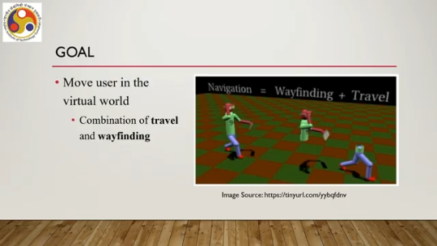
I would say a change of the user's viewpoint. Now, there are actually two parts in any such movement. One is the travel part. And the other is called the wayfinding part. Now the travel part is also known as the locomotion and
the corresponding techniques that are used to let the user travel in a virtual world from one place to another are called locomotion techniques or alternatively travel techniques. Now, travel is the motor component of navigation. That is the actual movement when we actually move our legs or limbs to move from one point to another. That is the motor component of movement that we generally refer to as the travel or locomotion part of navigation. So, essentially it refers to the movement between two locations, from one point to another.
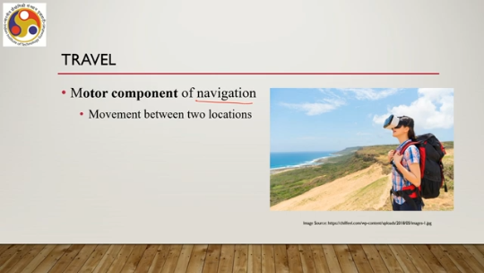
Now, there are different techniques employed to let the user perceive that travel has taken place. Travel can be done in different ways. One is exploration. It means that there is no explicit goal to reach. I mean there is no specific point where the user wants to reach.
The user instead just wants to move around, to see things, to learn things, to explore things. So that is the exploration type of travel. Then we have search. Searching for a specified target location. Or moving to a specified target location.
So, the user now, instead of exploration, wants to move to a specific location that comes under this type of travel. The third technique is maneuvering. It essentially refers to short, precise movements changing the point of view or the viewpoint. So, when we are traveling from one point to another, Either we can do the traveling at one go, or we can travel as a combination of smaller, short, specific, focused travels.
That means a path is broken down into small segments, and travel between each segment is performed so that at the end we reach the destination. So, this type of movement where the overall movement comprises short precise smaller movements is called maneuvering. So, we can have different ways to travel from one point to another; now these traveling these traveling types can be accomplished using four broad types of locomotion techniques. We can have locomotion based on walking, that is walking-based locomotion, then steering-based locomotion, then selection-based locomotion, and finally, manipulation-based locomotion.
Remember in our earlier part of the discussion we said that object interaction and navigation are different in the sense that in object interaction typically, manipulation of objects is involved whereas in navigation that is not generally the case. Object manipulation may not be involved. That is true for the first three types of locomotion techniques. However, in the last technique
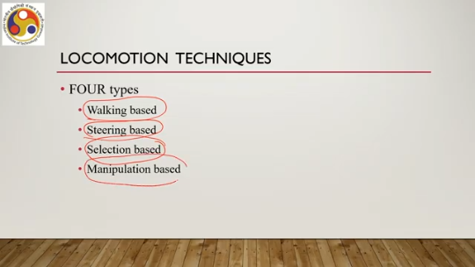
we do navigation by manipulating certain things that we will discuss at the appropriate time. So, manipulation is not entirely avoided while implementing travel techniques in an immersive setting. However, mostly navigation involves no manipulation of objects. Now, let us try to understand each of these techniques one by one. We will start with the first technique, which is walking-based locomotion.
As the name suggests, walking-based locomotion refers to traveling in the virtual world by physically walking in the physical world or the real world. So, some sort of walking or some sort of movement, physical movement is involved For corresponding virtual movement in the virtual world. Now, this type of locomotion can further be divided into several categories, broadly three categories. One is full gait technique, partial gait techniques and gait negation techniques.
So, these three are the broad categories of walking-based locomotion techniques: full gait, partial gait and gait negation techniques. What happens in full gait techniques? That actually involves real walking. So the user actually walks in the real world and that walk gets translated to virtual movement in the virtual environment, in the immersive environment. Obviously, this is the most natural way to travel.
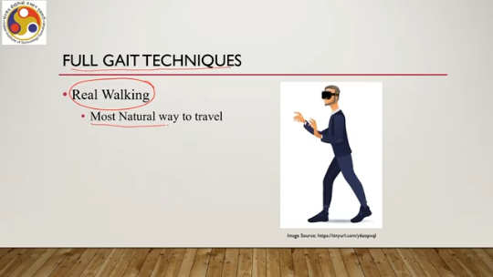
However, as we have seen earlier, giving a completely free form of walking is not practical or possible for virtual navigation. Instead, the walking is restricted within a specified limit in the physical space, which then gets translated to any amount of movement in the potentially infinite virtual space. So, of course, there is a mismatch, although this provides natural form of interaction for navigation as compared to the other techniques.
Then comes the second technique, that is partial gait technique. Unlike the previous full gait technique, here partial gait refers to the fact that the user walks but walks in place. That means the user does not actually change the position. As shown in this figure here, as you can see in this animated figure, the user is walking but in a single place. It is not actually moving forward, backward, left, or right.
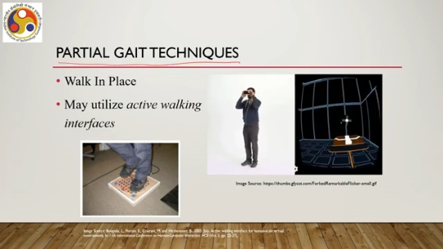
That is the partial gait technique. Now, implementation of these types of techniques may involve walking interfaces, active walking interfaces such as pressure mats, pressure sensors and/or interfaces with pressure sensors and so on. So that depending on the walking behavior, although it may be in a single place, but depending on the behavior of walking in that single place, the pattern can be mapped to different types of walking in the virtual space.
So, partial gait techniques require some sort of specialized devices in addition to other immersive hardware for providing input. Now, in case of gait negation technique, even more specialized setup is required because in such technique, the user's lateral movements are canceled due to the specified or specialized setup used, keeping their physical position fixed. So, although the user may be moving in multiple directions, the lateral movements in that movement pattern get negated, get canceled because of the specialized setup used and the user or the system maps that movement
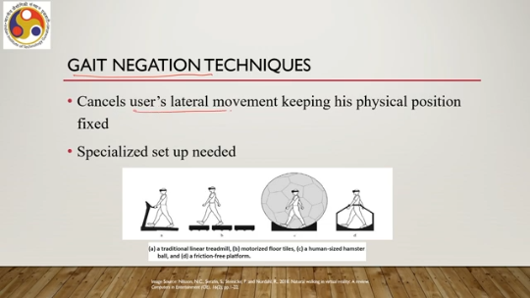
to a specialized or specific type of virtual movement. So, the user may be walking naturally. However, natural movement involves lateral movement. But to map that type of absolutely natural movements to a particular type of focused movement in the virtual world may be difficult. So, a specialized setup is used to
Cancel the lateral movements of the user so that it is easier for the system to understand the user's intention and accordingly perform the navigation in the virtual world. So, what kind of specialized setup is used? So, for example, a linear treadmill may be used. Motorized floor tiles may be used. A human-sized hamster ball may be used.
Or a friction-free platform may be used. These are some of the techniques. Of course, there can be other setups possible. Now, using this type of specialized setup, whatever lateral movement takes place can be detected and eliminated before the movement is mapped to the virtual navigation. Now, all these are part of walking-based navigation.
The second category of navigation is steering-based. It indicates continuous control of direction and speed while the user is moving from one point to another. So, whenever there is a continuous control of direction and speed, essentially we can safely assume that the system has implemented steering-based navigation. Now, this is also of two types. Spatial steering-based navigation.
In this case, the navigation is controlled using the user's body parts and physical steering-based navigation, where the navigation is controlled; the locomotion is controlled using vehicular props or some additional hardware. What is the spatial steering-based locomotion technique? So, it can be gaze-directed, that is, the travel follows where the user is looking. So, just by looking at a distance, we can move continuously to that target location.
So, it follows the direction of looking. Then it can be hand-directed. Hand direction determines direction of travel. So, we can provide the direction through hand gestures, and then correspondingly the system maps those hand gestures to travel in a specified direction where the hand is pointing.
It can also be body-leaning directed. So, we lean the body toward the direction of movement, and then that gets mapped and then corresponding travel takes place. As opposed to that, where we are using our body parts like gaze, eye, or hand, or whole body, there is a physical steering-based locomotion technique category as well, which involves some physical setups, some separate hardware such as bike locomotion platforms, VR simulators for aircraft, merchant ships, cars, boats, spaceships.
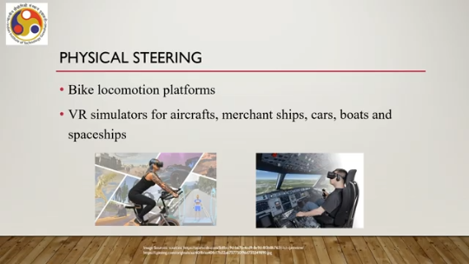
These actually come with this type of physical steering as shown in this example. So, this is a bike simulator where you can see the physical steering, and by moving the steering physically, you can perform the travel in the virtual world. Similarly, here you have physical steering props which are used to In this flight simulator here, which is used to perform travel in the virtual world. So that is about walking-based and steering-based.
The third category is selection-based navigation or locomotion technique. Now it allows users to focus on where to go rather than how to. In the previous techniques, user has to specify by moving the steering or looking at the direction continuously or performing work for movement; user has to specify how to reach a destination, whereas in case of selection-based, user can focus on where to go, need to select where to go rather than specify how to go there.
Now this locomotion technique category can also be of different types. We can have target selection-based locomotion; we can have route planning-based locomotion. In case of target selection-based locomotion, what happens is that the user selects the destination or the target where the user wants to move. And the virtual viewpoint changes. Or in other words, it lets the user feel through that change that the user has actually moved to the target.
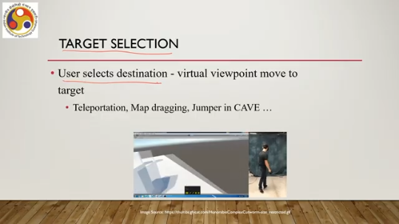
One very common such technique is teleportation. That is instantly moving target. from current location to the target location. Similarly, with map dragging, if we fix the location, then we can instantly move there. Another technique is the jumper technique in cave-type systems.
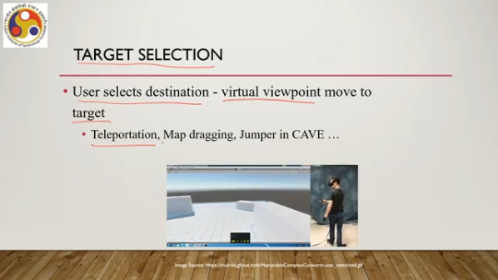
So, as shown in this small animation, the user here is selecting the target and then immediately the viewpoint changes. As if there is an instant travel taking place from the current viewpoint to the destination viewpoint. This is an example of teleportation. The next type of technique is route planning. This is also another type of selection-based technique.
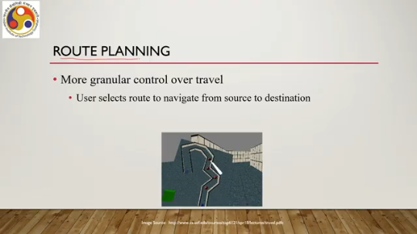
However, in this case, it is not that only the end is selected. It can provide more granular control over travel, unlike teleportation or target-based locomotion where only the endpoint is selected and we instantly move there. In the case of route planning, what happens is that instead of the target, we select a route that takes us to the target. There may be multiple routes. And the user selects a route that takes them to the target in the virtual world, and while moving through that route, different viewpoint changes are implemented so
that the user feels they are moving along a path. So, it is a slightly more natural kind of movement as compared to target-based teleportation-type movement. So those are about selection-based. The final category of locomotion techniques is manipulation-based locomotion techniques.
Here the locomotion works by manipulating the user's position, orientation, or scale using gestures that control either the virtual viewpoint or the virtual world. Earlier we have talked about the go-go technique, homer technique, and world in miniature metaphor. So, using a combination of these different manipulation techniques and metaphors, we can implement manipulation-based locomotion. Say for example, in a world in miniature metaphor, if we move certain objects, then correspondingly or manipulate certain objects, then corresponding change in viewpoint happens as if the user is moving from one place to another.
So, this type of implementation is possible through manipulation-based locomotion techniques. Since we have already discussed these techniques before, we are not going to discuss further what is go-go or what is homer manipulation or what is world in miniature. Please refer to the previous discussions. Previous lectures for discussion on these concepts. So, with that we have come to the end of our discussion on locomotion techniques.
Now, if you recollect the other component of locomotion is wayfinding; the other component of navigation is wayfinding. So, there are two components of navigation: one is locomotion or travel, that is the motor component and The second component is wayfinding. So far we have discussed the motor component. Now, let us move our attention to the wayfinding component.
Now, wayfinding refers to many things such as location awareness where one is located, and ascertaining a path through the environment to the desired destination. transferring spatial knowledge to the real world. So, essentially it refers to a mental model. So, the goal of wayfinding is basically to build a mental model or a cognitive map of the surroundings as well as the overall environment so that it is easier for us to locate ourselves in the environment as well as to identify a suitable path
to take us to the destination. Now our objective should be to design the environment in a way such that it is easier for the user to build such a mental map. If it is missing, if the design does not support creation of this mental map then a lot of problems may happen and that will have a deteriorating effect on the overall user experience. Now, when we talk of spatial knowledge in that mental model or the cognitive map, what we are referring to is landmark knowledge, procedural knowledge and topological or map-like knowledge. So, we should have knowledge about landmarks in our surroundings as well as in other places
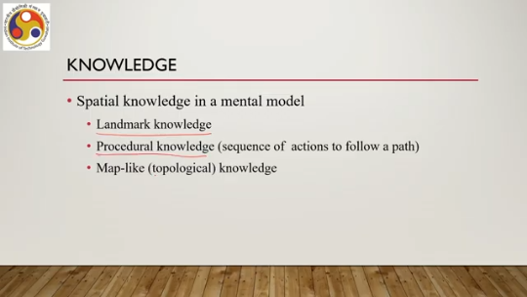
some sort of procedural knowledge or the sequence of actions required to follow a path and overall map of the environment or topological knowledge of the environment. Together they constitute the knowledge base which is required or which is an essential part of the overall mental model. Now how can we create the mental model? Essentially by aiding the user to get the knowledge, to understand the knowledge or to infer the knowledge.
So essentially this can be done by the traditional methods: systematic study of the map of a place, exploration of real space, exploration of a copy of the real space, or a model of the real space. Either method or a combination of all may give us the mental model or the cognitive model. Then what is required for the system to provide a good user experience, immersive user experience, is some sort of support for wayfinding. Note that it is not sufficient to provide good travel support only.
Along with that, we need to provide good wayfinding support so that the travel supports are effectively used or deployed by the user while performing navigation. So without suitable wayfinding support in a complex environment, irrespective of how many different types of traveling techniques are implemented, the user will not be able to perform efficient movement. So how can we provide wayfinding support?
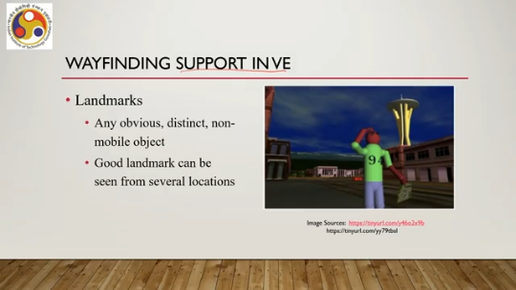
Say one way is to have landmarks. These are any obvious distinct non-mobile objects that are positioned in a given place. A good landmark can be seen from several locations. So it should be clearly visible from different points of view, different locations. We can also provide support for maps of the space, of the place.
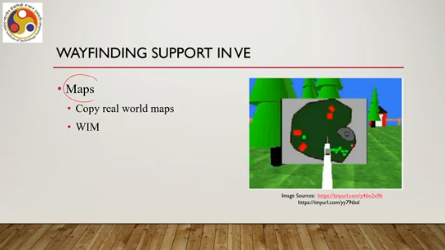
It can be a copy of the world map. In fact, here the term world refers to the virtual world, not the real world, or it can be a world in miniature. So, for example, here it shows a world in miniature type of Wayfinding support which shows the entire world with the objects located at different points, and it can also show the user's current position. and different ways to reach different points, many things.
Another way the wayfinding can be supported is through path following; that is, multiple paths through a single space may be denoted by colors, so that the user knows that there are different paths to reach a destination. Breadcrumbs can provide Another kind of support, it is essentially the idea to leave a trail of the path followed by predecessors. So, leaving a trail of markers allows the users to know when they have been somewhere before.
So, that the user does not get lost; the user knows that this path is explored. So, let us move to a different path or different destination to save time and so on. A simple aid can be a compass; another form of direction indicator can specify directions in both 2D or 3D space. So, accordingly, a compass can be designed and placed in the environment. So, there can be different ways to support wayfinding.
The most crucial thing is to remember that support for wayfinding is an essential requirement if you are designing a complex virtual environment with lots of objects and different ways to reach the targets. Without proper wayfinding support, irrespective of the sophistication of the travel support, the user may not be able to deploy them efficiently or effectively. So that is about it. Wayfinding, and with that we can conclude the discussion on navigation techniques.
The third interaction technique is interaction for system control. Now here the goal is to issue commands to change system state or mode, such as launching an application, changing the system settings, opening a file, and so on. Most of the regular operations that are associated with using any software. And correspondingly, there are several ways to perform those tasks through interactive methods. Different interaction techniques are there for system control.
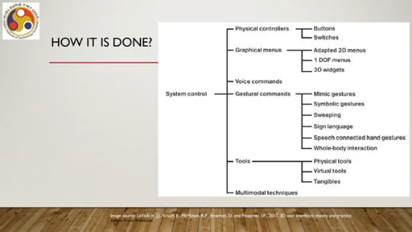
One can be physical controllers such as buttons, switches. Then we have graphical menus, adapted 2D menus suitable for 3D massive environments, one degree of freedom menus, 3D widgets. Then we can also have voice commands to perform the controls, gesture commands such as mimic gestures, symbolic gestures, sweeping gestures, sweeping gestures, sign language, speech-corrected hand gestures, whole-body interactions; all sorts of regular interaction modes can be deployed. We can also have tools such as physical tools, virtual tools, tangible interfaces, and we can
combine multiple techniques to have multimodal interaction techniques for system control, where we can combine, say, voice with gestures or other sorts of interactions. So, with that we can conclude this part of the lecture, where we have covered the navigation interaction and interaction for system control. So, at the end, let us quickly summarize what we have discussed so far. We have learned the idea of design, essentially interface and interaction. Then we talked about design guidelines which can provide a starting point for a designer.
Then we talked about interaction techniques typically used in immersive settings, primarily VR and also MR, not very important for AR. There we talked about object interaction, comprising object selection and object manipulation. We also talked about navigation interaction, comprising travel and wayfinding. And finally, we briefly touched on interactions for system control, which is more of a regular type of interaction with any software. In the next part of the lecture, we are going to talk about the design of the Majuli VR Tour.
What are the elements? of design that are specific to the Majuli VR Tour and how we arrived at those design ideas. So, I hope you could follow the concepts and topics and that they were interesting to you. So, we will continue our discussion on design in the next part of the lecture as well. So, looking forward to meeting you in the next lecture.
Goodbye, thank you, and happy learning.

